**UCS1712 – GRAPHICS AND MULTIMEDIA LAB**

**Ex. No.11 Image Editing and Manipulation**

**Date:** 11/10/21 **Name:** Srinath S

**Class:** CSE-C  **Roll:** 185001205

**Question:**

a) Using GIMP, include an image and apply filters, noise and masks.

b) Using GIMP, create a GIF animated image.

**Output Screenshots:**

**Answer A):**

**Original image:**

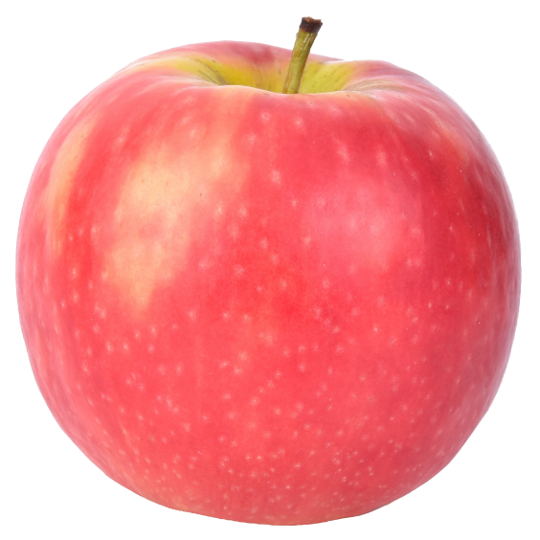

**With Filter applied:**

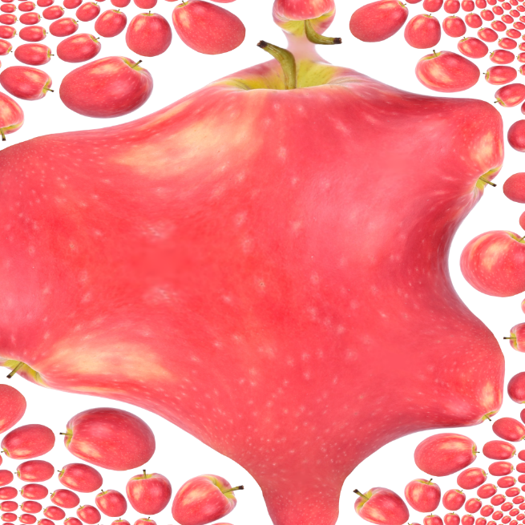

**With noise applied:**

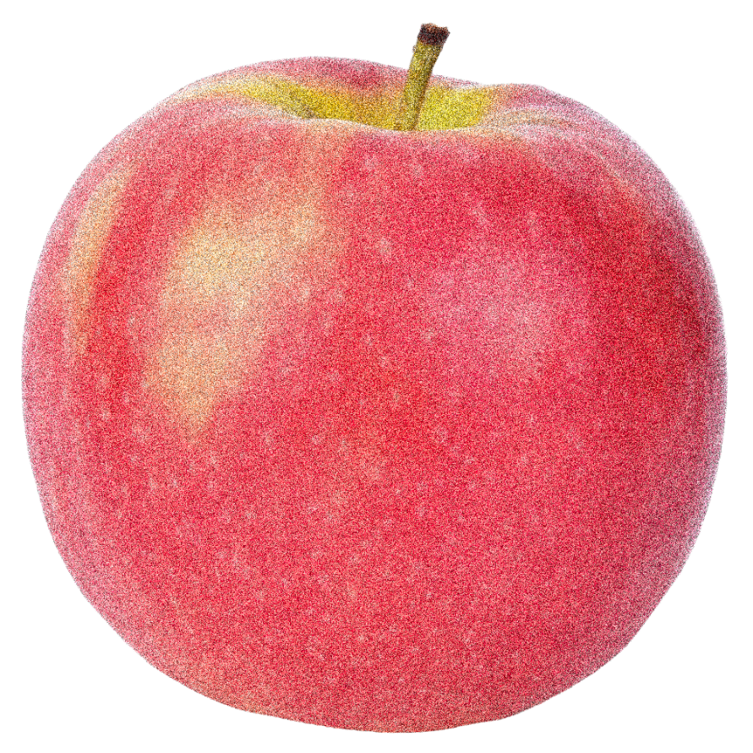

**With mask applied:**

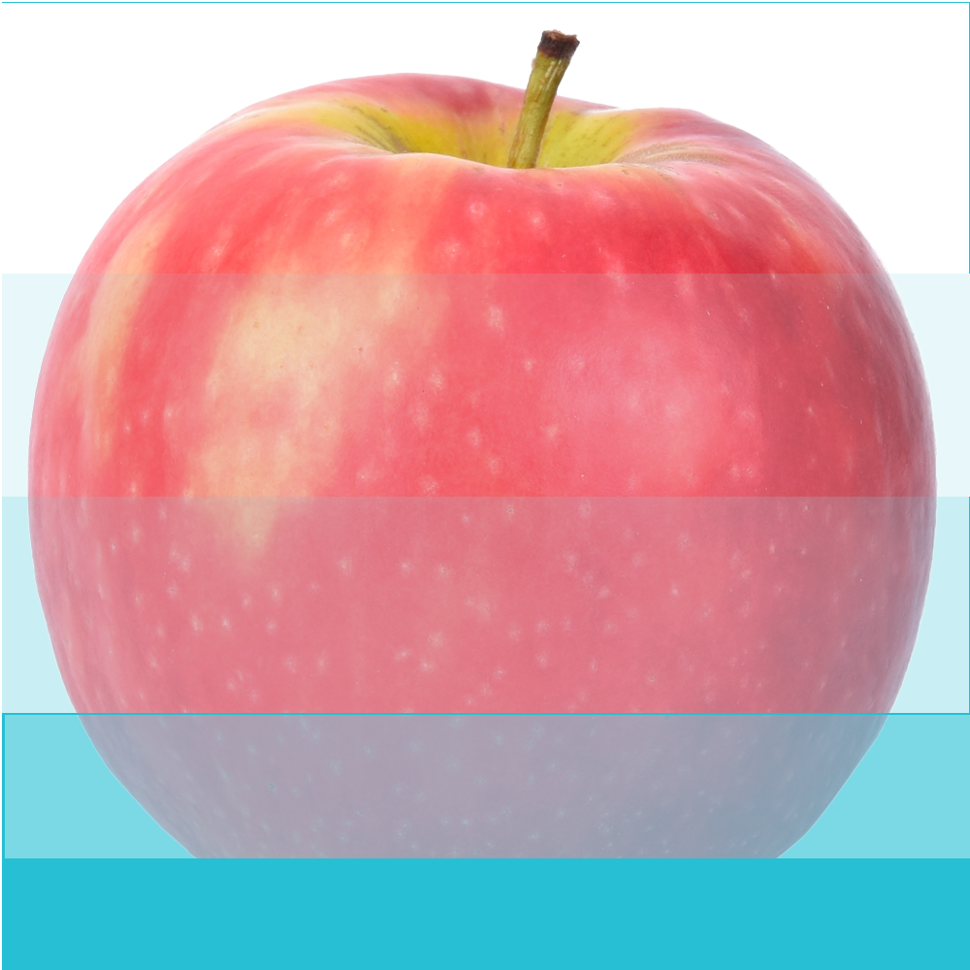

**Answer B) GIF:**

